**Task 1: Introduction to Excel and Formulas**

**Objective:** The objective of this task is to gain familiarity with Excel and basic formula usage for data manipulation.

**Instructions:**

1. Open Excel or Google Sheets: Launch either Microsoft Excel or Google Sheets on your computer.
2. Create a New Workbook: Start a new workbook or spreadsheet to work with.
3. Import Sample Dataset: Import the provided sample dataset into the spreadsheet. You can do this by copying and pasting the data or importing it from an external file (e.g., CSV).
4. Use Formulas: Utilize formulas to perform calculations on the dataset. Commonly used formulas include:
   * SUM: Calculate the total of a range of cells.
   * AVERAGE: Compute the average value of a range of cells.
   * MAX: Find the maximum value in a range of cells.
   * MIN: Find the minimum value in a range of cells.
5. Apply Conditional Formatting: Apply conditional formatting to highlight specific cells based on predefined conditions. For example, you can highlight cells with sales greater than $1000 in a different colour.

**Example Output:** Include screenshots or snippets of your Excel or Google Sheets spreadsheet showing:

* The imported sample dataset.
* The formulas used to perform calculations (e.g., SUM, AVERAGE).
* The application of conditional formatting highlighting cells meeting specific criteria.

**Deadline:** This task is due by today

Solutions:  
This is the data I downloaded form the web: 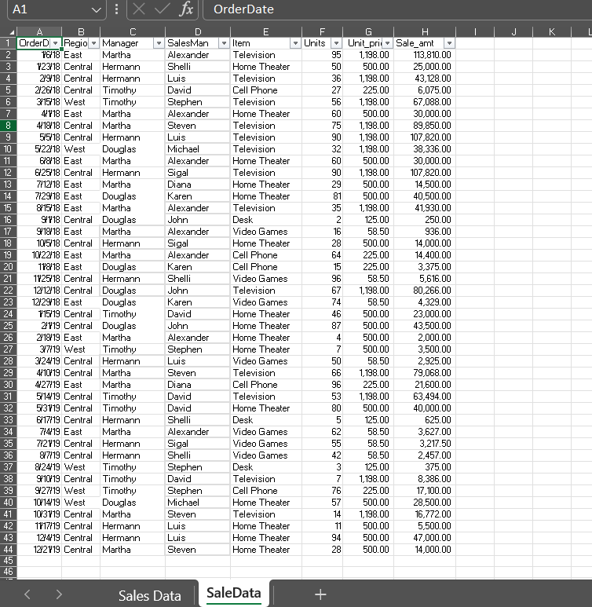

Then I start counting the total item no & total sales man no by formula:  
Total Item sales man =COUNTA(UNIQUE(D2:D44))

Total Item no=COUNTA(UNIQUE(E2:E44))

Then I start to cunt the total unit sold and plot a bar graph for it :

|  |  |
| --- | --- |
| Total Unit Sold | |
| Television | 716 |
| Home Theater | 722 |
| Cell Phone | 278 |
| Desk | 10 |
| Video Games | 395 |

The formula used for it is :

=SUMIF($E$2:$E$44,J8,$F$2:$F$44) i.e., sumif(range, criteria,sum_range)

In the similar way I find out the Total Amount Sold :

|  |  |
| --- | --- |
| Total Amount Sold | |
| Television | 857768 |
| Home Theater | 361000 |
| Cell Phone | 62550 |
| Desk | 1250 |
| Video Games | 23107.5 |

And I calculate the total revenue :

|  |  |
| --- | --- |
| Total Revene | 1305676 |

I highlight the highest sales and lowest sales using conditional formatting : 